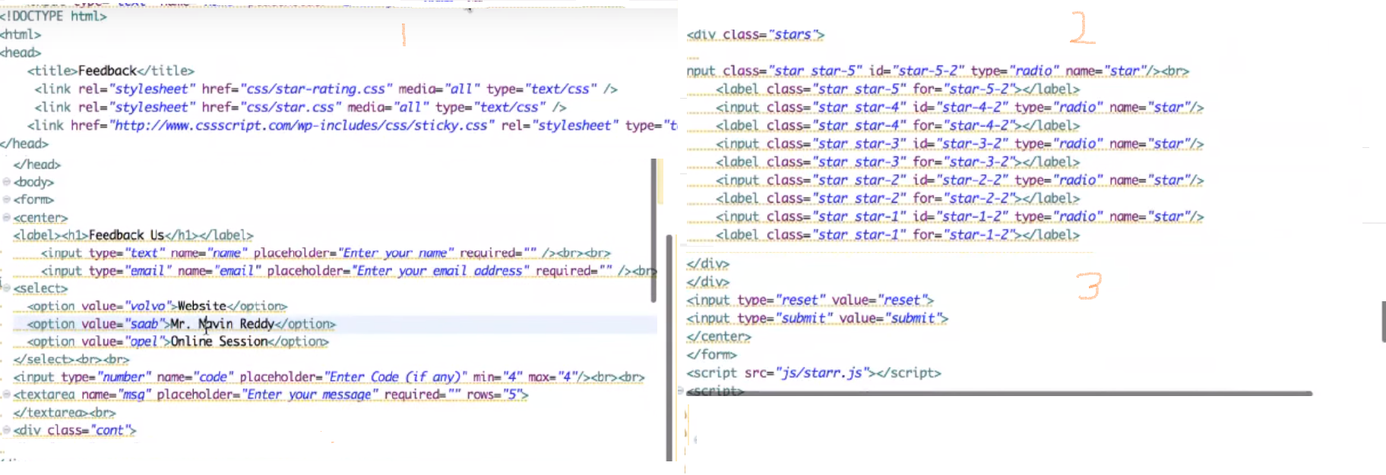

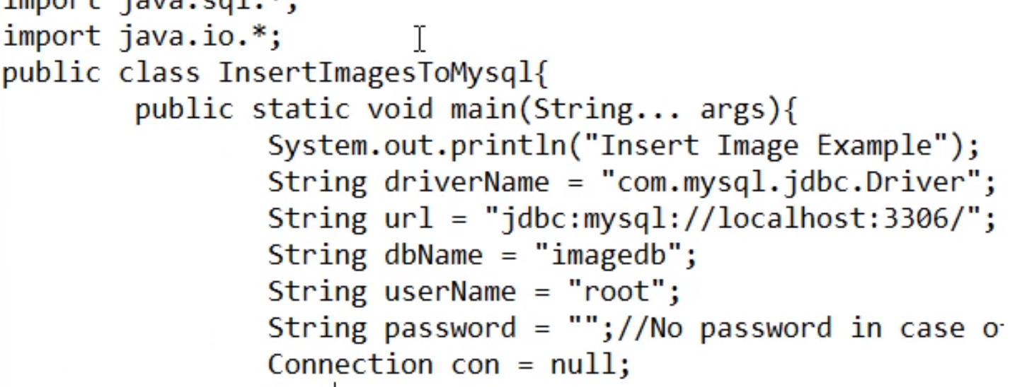

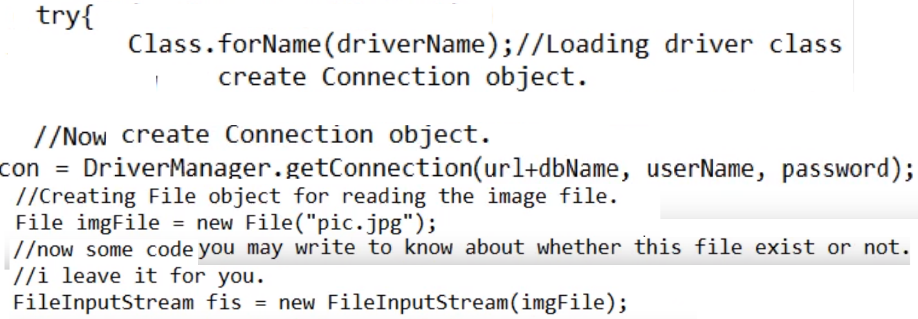

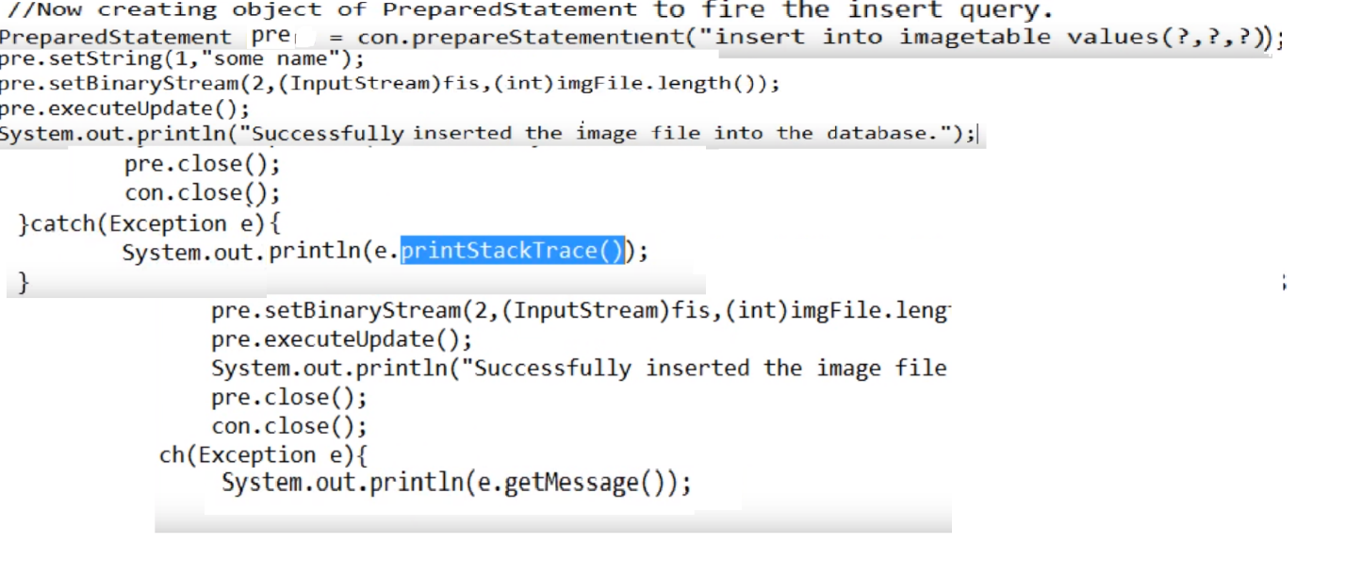

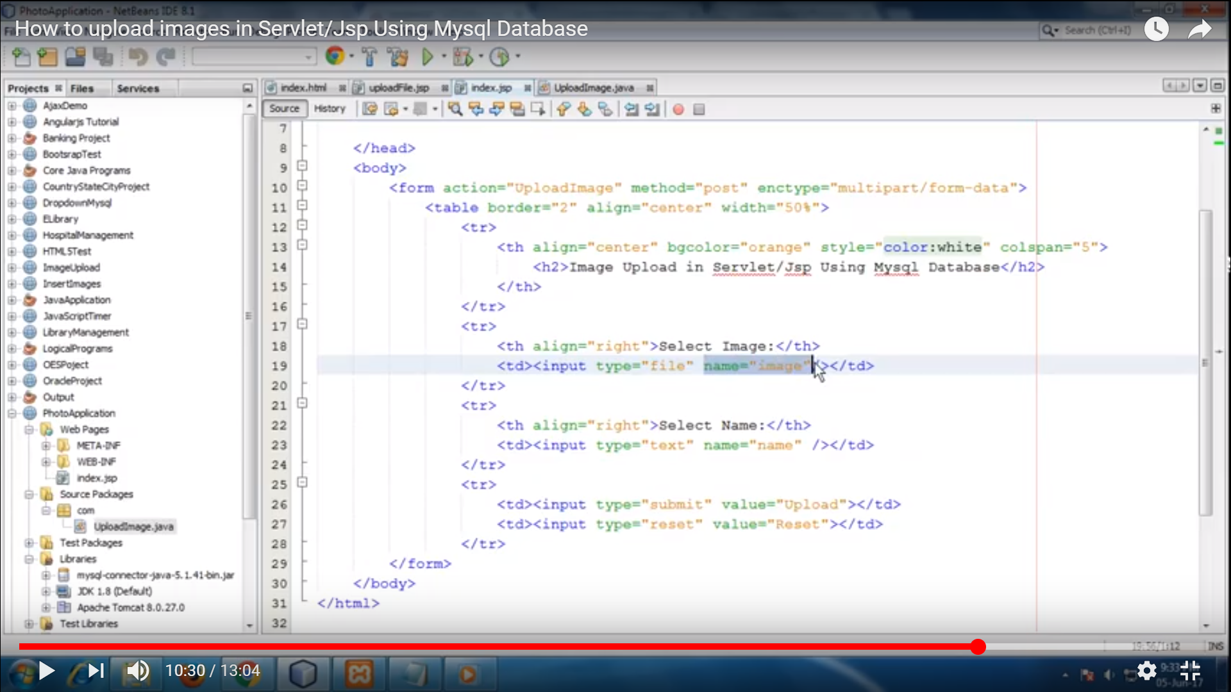

Pertaining to columns in your table:

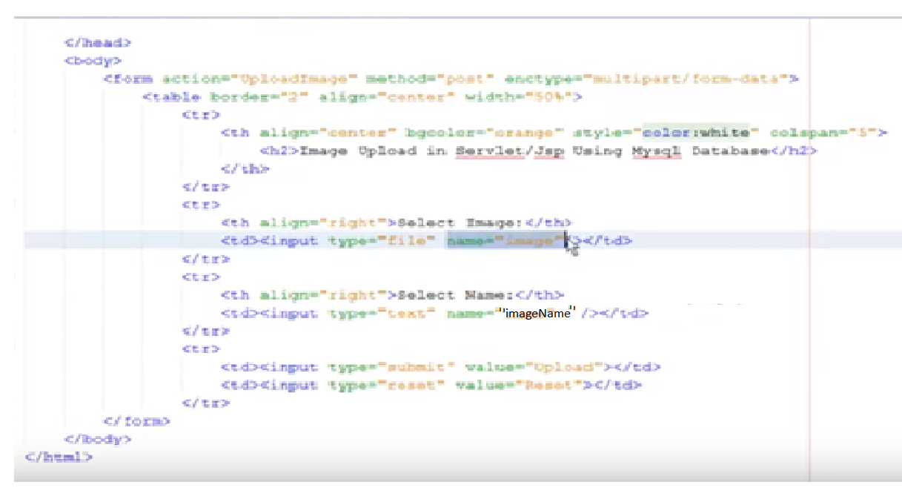

Before Selection:

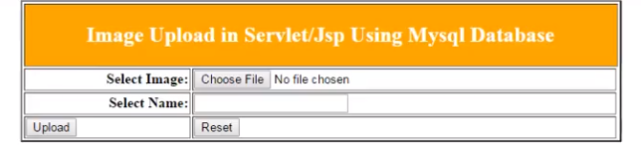

After Selection:

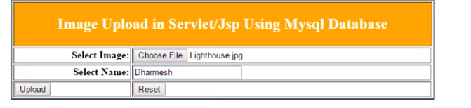

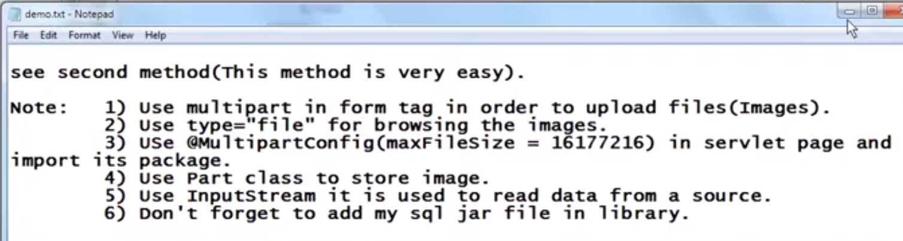

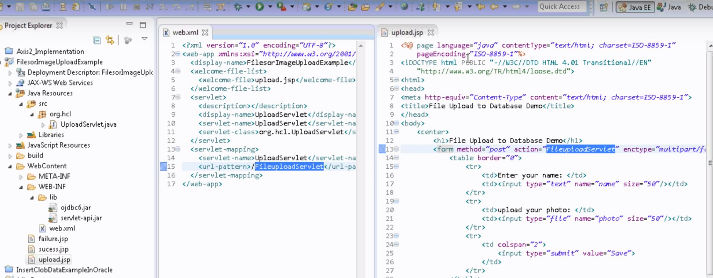

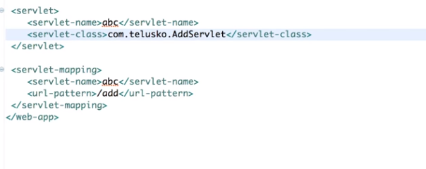

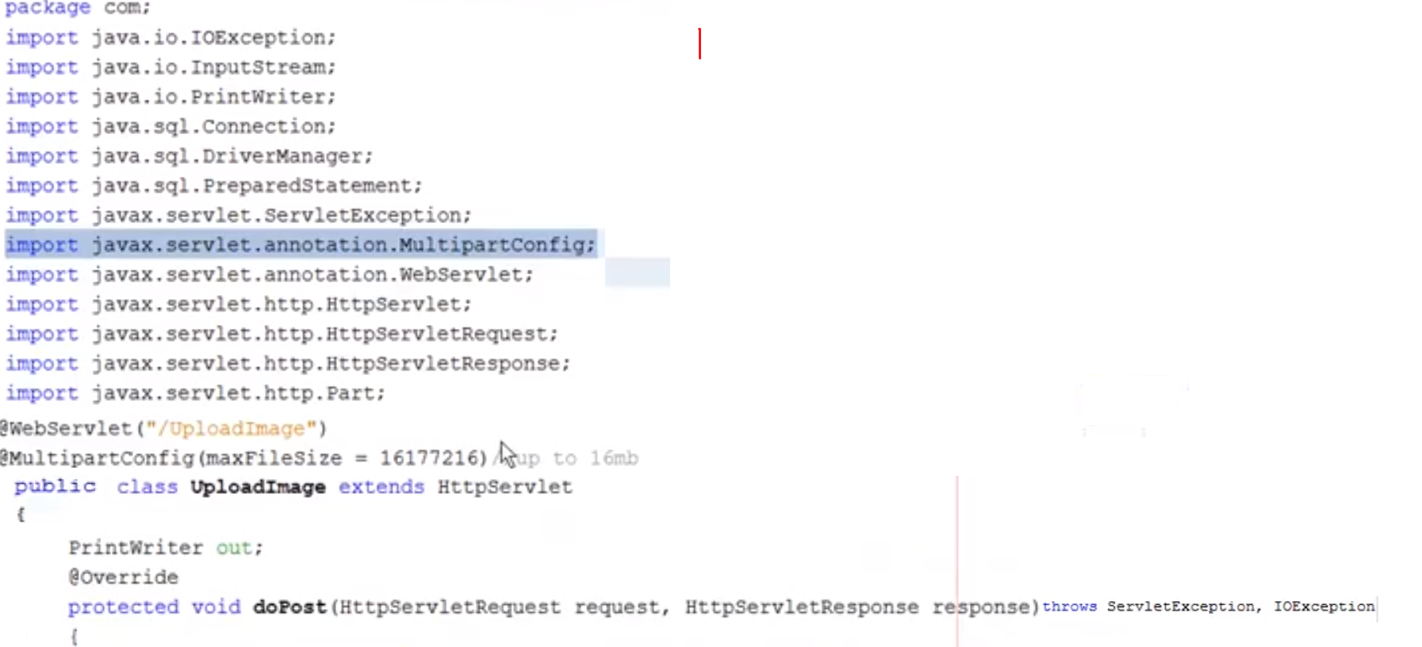

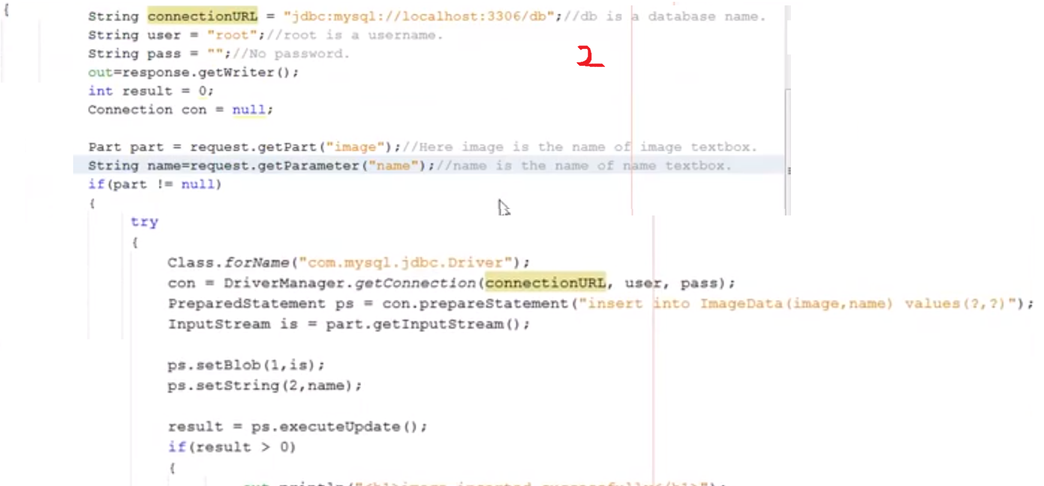

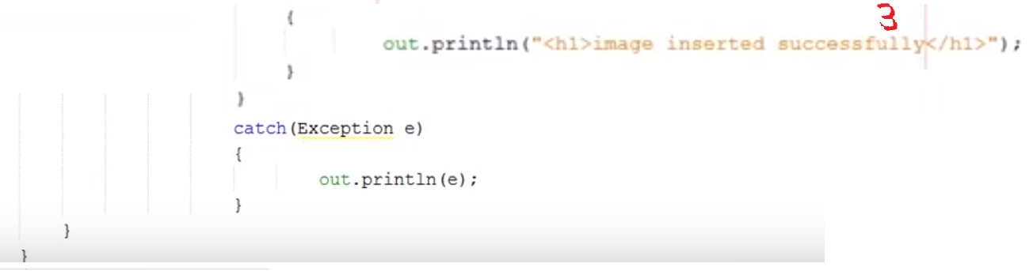

/**

* Upload single file using Spring Controller

*/

@RequestMapping(value = "/uploadFile", method = RequestMethod.POST)

public @ResponseBody ResponseEntity<GenericResponseVO<? extends IServiceVO>> uploadFileHandler(@RequestParam("name") String name, @RequestParam("file") MultipartFile file,HttpServletRequest request, HttpServletResponse response) {

if (!file.isEmpty()) {

try {

byte[] bytes = file.getBytes();

// Creating the directory to store file

String rootPath = System.getProperty("catalina.home");

File dir = new File(rootPath + File.separator + "tmpFiles");

if (!dir.exists())

dir.mkdirs();

// Create the file on server

File serverFile = new File(dir.getAbsolutePath() + File.separator + name);

BufferedOutputStream stream = new BufferedOutputStream(new FileOutputStream(serverFile));

stream.write(bytes);

stream.close();

System.out.println("Server File Location=" + serverFile.getAbsolutePath());

return null;

} catch (Exception e) {

return null;

}

}

}

**Html related to QR code below:**

